Warnings – Engine Warming Please Wait and Ok to Drive

Functional Description

The purpose of the Engine Warming Please Wait Warning is to inform the driver of a diesel vehicle that after being started under extremely cold conditions the vehicle needs to sit at idle for a period of 30 seconds in order to warm the engine oil. During the period the engine is warming the oil, the PCM will take control of the throttle and not allow engine RPM above idle. This action is performed by the PCM in order to insure the motor has proper lubrication prior to driving at cold temperatures.

After idling for 30 seconds the PCM will then turn over throttle control to the vehicle operator and the cluster will display the TA* message “Ok to Drive”.

A third message is now added to inform the customer that although it is ok to drive reduced engine power will be experienced for an additional period of time while the engine further warms up. This warning is only expected to be displayed at extremely cold temperatures or at high altitudes.

The Engine Warming Please Wait and Ok to Drive Warnings correlate the EngTeColdPrtct_D_Stats (HS_CAN) signal from the PCM and the Operational_Mode to determine when to display the Engine Warming Please Wait or Ok to Drive message center warning messages.

Interfaces

1.2.1 Interface Context Diagram (I/O Block Diagram)

Figure 1 Warnings – Diesel – Engine Warming Please Wait and Ok to Drive Context Diagram

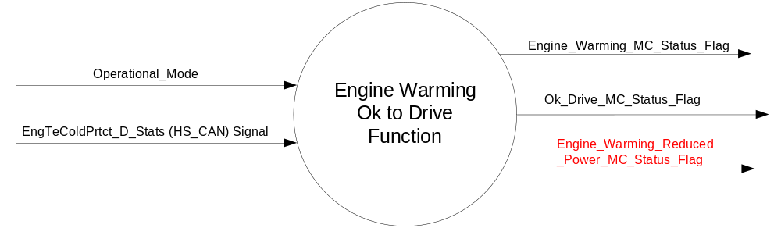

1.2.2 Inputs
      - INTERNAL:
    - Operational_Mode
- MUX message from the HS_CAN bus

- Message 0x155
Message Name | Transmitter | Message Identifier | DLC | TX Model | Period
_DieselData_1 | ECM | 0x155 | 8 | Fixed Periodic | 20

- EngTeColdPrtct_D_Stats (HS_CAN) Signal
Signal Name | ID | Size  (bits) | Pos.  (bit) | Detail | Units | Res. | Offset | State Encoded | Min. | Max.
EngTeColdPrtct_D_Stats | 0x155 | 2 | 49 |  | SED | 1 | 0 |  | 0(0x0) | 3(0x3)
EngTeColdPrtct_D_Stats |  |  |  | Normal_Operation |  |  |  | 0x0
EngTeColdPrtct_D_Stats |  |  |  | Engine_Warning |  |  |  | 0x1
EngTeColdPrtct_D_Stats |  |  |  | OK_to_Drive |  |  |  | 0X2
EngTeColdPrtct_D_Stats |  |  |  | Engine_Warm  _RdcPwr |  |  |  | 0X3

Outputs
- Engine_Warming_MC_Status_Flag
- Ok_Drive_MC_Status_Flag
- Engine_Warming_Reduced_Power_MC_Status_Flag

Function/Performance

Operational Modes

Mode | Differentiating Vehicle Conditions
Sleep Mode | OFF
Limited Mode | OFF
Normal Mode | Please Wait Engine Warming_Ok to Drive Warning Text Messages ON / OFF
Crank Mode | Please Wait Engine Warming_Ok to Drive Warning Text Messages ON / OFF

The above table references the setting of the Warning flags as per this section. However, the actual warning display operational modes are defined in the Message Center section of this SPSS.

Voltage Levels

Refer to the Cluster Features Table located in the Operational Modes and Voltage Range Strategies Section of this SPSS

Human-Machine Interface

Visual

1.3.3.1.1 Indicator Graphics / Display Format
Message Center Text Warning Message as defined in section 1.3.5.7 of this document.

1.3.3.1.2 Indicator Color Coordinates

Reference section COLOR & ILLUMINATION REQUIREMENTS (GRAPHICS).

Audio

None.

Switch Control Logic

None.

System Accuracy

Within 100 msec of receiving a message that results in a change of state the cluster will update the output flag to the proper state.

Operation: Performance and Functional

Subsystem Algorithm Flowchart / State Diagram

- State Matrix for Engine Warming and Ok to Drive Messages
Operational_  Mode | EngTeColdPrtct_D_Stats  (HS_CAN) Signal | Engine_Warming_  MC_Status_Flag | Ok_Drive_MC  _Status_Flag | Engine_Warming_Reduced  _Power_MC_Status_Flag
Normal or Crank | (0x1) | Active | Inactive | Inactive
Normal or Crank | (0x2) | Inactive | Active | Inactive
Normal or Crank | (0x3) | Inactive | Inactive | Active
All Other Cases |  | Inactive

- Engine Warming MC Status Flag to MC Warning Message ID
Engine_Warming_  MC_Status_Flag | Ok_Drive_MC  _Status_Flag | Engine_Warming_Reduced  _Power_MC_Status_Flag | MC Message ID
Inactive | Inactive | Inactive | None
Active | Inactive | Inactive | W705
Inactive | Active | Inactive | W715
Inactive | Inactive | Active | W714

Figure 2 Engine_Warming_MC_Status_Flag = Active Detailed Function

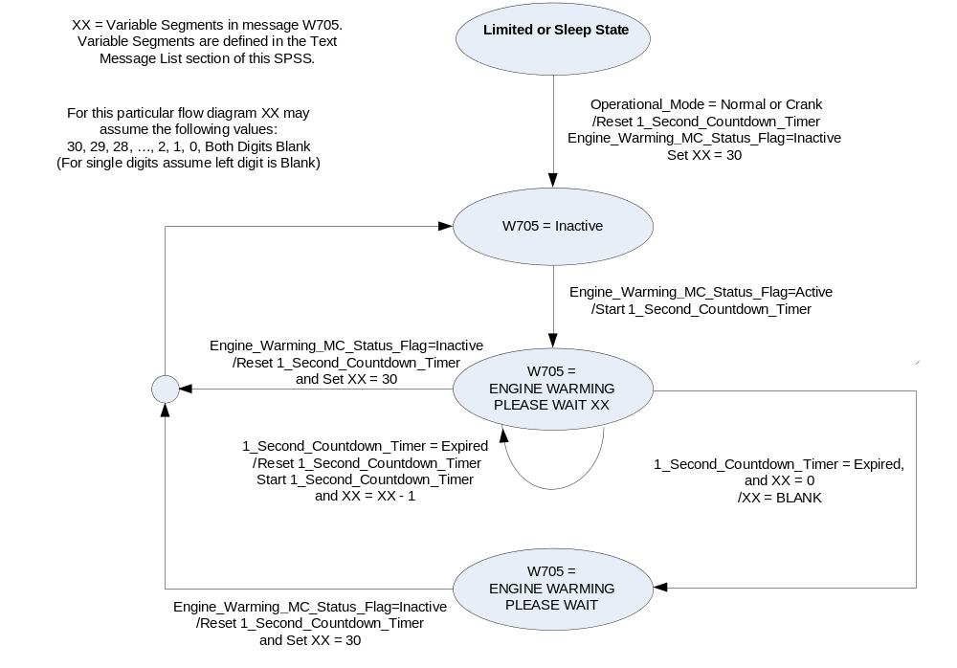

Operation Description (supports algorithm flowchart /state diagram)

- For definition of how the Message Center arbitrates and displays Active warnings, see the Warning / Alert Display Logic Diagram, located in the Message Center – X Display with W Button Interface section of this SPSS (where X and W are appropriate values in this document).
- System Check: There is no System Check content for Engine Warming or Ok to Drive Warnings.

Function Safety Classification (EMC)

Class B

Memory Storage
Parameter Name | Description | Value at  Battery Connect | Value at  Module Wake-up
EngTeColdPrtct_D_Stats (HS_CAN) Signal | CAN Signal sent from the ECM | Normal_Operation (0x0) | Normal_Operation (0x0)
Engine_Warming_MC_Status_Flag | State variable used by M/C Warning Arbitrator | INACTIVE | INACTIVE
Ok_Drive_MC_Status_Flag | State variable used by M/C Warning Arbitrator | INACTIVE | INACTIVE
Engine_Warming_Reduced  _Power_MC_Status_Flag | State variable used by M/C Warning Arbitrator | INACTIVE | INACTIVE
1_Second_Countdown_Timer | Used to control 30second countdown display | INACTIVE | INACTIVE
XX | State variable which represents countdown value displayed to operator | 30 | 30
Operational_Mode | 4 state indicator for cluster operational mode | Limited | Limited or Normal or Crank

Prove Out

No.

Reconfigurable Telltale

No.

Message Center Msg

Warning Message ID W705, W714, and W715 as defined in the Text Message List section of this SPSS.

Error Handling

Missing Message Strategy

Missing Message DTCs can only be logged when DTC_Possible is TRUE. The definition of when DTC_Possible is TRUE is defined in the Diagnostics Section of this SPSS. Missing Message Timers shall only be ACTIVE when DTC_Possible is TRUE. Missing Message Timers shall be stopped and reset when DTC_Possible is FALSE.

When DTC_Possible is TRUE and _DieselData_1 message is missing, MMT_C100_155 shall be started. MMT_C100_155 shall be stopped and reset when DTC_Possible is FALSE or _DieselData_1 message is received.

When MMT_C100_155 is equal to or greater than 5 seconds, the _DieselData_1 message and all of its signals shall be declared MISSING and the cluster shall log DTC C10000 and the Engine_Warming_MC_Status_Flag and the Ok_Drive_MC_Status_Flag shall default to Inactive. When MMT_C100_155 is ACTIVE and less than 5 seconds, the Engine_Warming_MC_Status_Flag and the Ok_Drive_MC_Status_Flag shall remain in the same state as prior to MMT_C100_155 becoming ACTIVE. The Engine_Warming_MC_Status_Flag and the Ok_Drive_MC_Status_Flag shall indicate as per state matrix within 100mS of receiving a valid message.

As this feature only exists on diesel variants, non-diesel instrument clusters shall never start MMT_C100_155.

Diagnostics

Self Test

None

Engineering Test Mode

Not Applicable

Part II Performance

Supported Diagnostic Trouble Codes (DTCs)
DTC | Description | When Logged
C10000 | Lost Communication with ECM/PCM | Message missing for more than 5 seconds

Reference Specification

IS-0001 WARNINGS/INDICATORS/DISPLAYS PROVEOUT
IS-0052 OPERATING VOLTAGES - FUNCTIONAL/PERFORMANCE
IS-0069 FUNCTIONAL IMPORTANCE CLASS
IS-0324 WINDSHIELD & OTHER REFLECTIONS
IS-0327 WARNING INDICATOR EVALUATION
IS-0379 NORTH AMERICAN WARNINGS AND INDICATORS STRATEGY

IL-0017 TELLTALE AND INTERIOR ILLUMINATION – COLOR AND INTENSITY
IL-0019 GENERAL ILLUMINATION DIMMING
IL-0021 CRAFTSMANSHIP – DISPLAYS
IL-0022 GENERAL ILLUMINTATION COLOR
IL-0023 CLARITY/LEGIBILITY/READABILITY/VISUAL CONTRAST
IL -0043 OPERATIONAL ENVIRONMENT FUNCTIONALITY
IL -0045 COLOR
IL -0047 TELLTALE, INDICATOR AND DISPLAY LIGHT INTENSITY
IL -0048 ILLUMINATION ACCEPTABILITY

03-0661 PLACEMENT: CONTROL AND DISPLAY LOCATIONS
03-0662 PLACEMENT: LOGICAL GROUPING FUNCTION AND USAGE
03-0664 PLACEMENT: DOWN VISION TO COMPONENTS WITH HIGH VISUAL DEMAND
03-0665 PLACEMENT: EXPECTED LOCATIONS OF CONTROLS AND DISPLAYS VDS
03-0670 INTERIOR VISIBILITY
03-0671 INTERIOR VISIBILITY: REFLECTIONS FROM COMPONENTS & SURFACES
03-0672 INTERIOR VISIBILITY: REFLECTIONS IN DISPLAYS
03-0673 INTERIOR VISIBILITY: VISUAL OBSCURATIONS
03-0674 INTERIOR VISIBILITY: ILLUMINATION CONTROLS / DISPLAYS
03-0675 INTERIOR VISIBILITY: VEILING GLARE
03-0677 INTERIOR VISIBILITY: SUNLIGHT WASHOUT
03-0681 IDENTIFICATION: CHARACTER AND SYMBOL SIZE
03-0682 IDENTIFICATION: LEGIBILITY
03-0685 IDENTIFICATION: SYMBOLS, ABBREV FOR CONTROL
03-0721 LOGIC OF OPERATION: OPERATIONAL STEREOTYPES
03-0722 LOGIC OF OPERATION: INTERPRETATION
03-0723 LOGIC OF OPERATION: USE OF SYSTEMS WITH VISUAL DISPLAYS

Revision History

SPSS Module Revision History

Revision Level | Name | Change Description | Date
1.0 | J. Gregoire | Updated for CGEA. Based on FNA Warnings - Diesel - Engine Warming Please Wait and Ok to Drive STSS V1.0  Section 1.3.1 – Update with standard text. | 7/16/2008
  From FNA | To CGEA
  HS-CAN Message 0x154  Additional_Engine_Data from HS_PCM | HS-CAN Message 0x155  _DieselData_1 from ECM
  Signal COLD_ENGINE_PROTECTION_STATUS  Normal (0x0)  Engine_Warming (0x1)  Ok to Drive (0x2)  Undefined (0x3) | Signal EngTeColdPrtct_D_Stats  Normal_Operation (0x0)  Engine_Warning (0x1)  OK_to_Drive (0x2)  Undefined (0x3)
   | MMT_C100_155
  DTC C100 | DTC C10000
  Mod Conf (Method 2) | DID DE00
2.0 | J.Blatchford | This change adds a text warning message for the condition where the vehicle has warmed up so it may be driven without damage to the turbo charger, however, due to extremely cold temperatures power output is physicaly limited for a short period of time. Changes in red.  - 1.1: Added third paragraph.  - Table 1.1: Changed unused in detail column to Engine_Warm_RdcPwr.  - Figure 1: Updated context diagram.  - Table 1.3: Added Table.  - 1.2.5.3: Removed reference to W#s as they are covered by Table 1.3.  - 1.4.3: Removed DID DExx table as there is no configuration associated with this feature.  Note: Engine_Warm_RdcPwr is proposed signal 0x3 detail text. If this does not match CMDB release a .1 revision update will be required. | 3/17/14
2.1 | J.Blatchford | Corrected numbering sequence. No design change. No DCR required. New programs only. | 7/19/2016

